For enabling Https for localhost , go to following website and download openssl (as per your system architecture)

<https://slproweb.com/products/Win32OpenSSL.html>

|  |  |  |
| --- | --- | --- |
| Win64 OpenSSL v3.4.0 [EXE](https://slproweb.com/download/Win64OpenSSL-3_4_0.exe) | [MSI](https://slproweb.com/download/Win64OpenSSL-3_4_0.msi) | 221MB Installer | Installs Win64 OpenSSL v3.4.0 (Recommended for software developers by the creators of [OpenSSL](https://www.openssl.org/)). Only installs on 64-bit versions of Windows and targets Intel x64 chipsets. Note that this is a default build of OpenSSL and is subject to local and state laws. More information can be found in the legal agreement of the installation. |

• **Run the Installer**:

* Double-click the downloaded .exe file to start the installation.
* During installation, when prompted to choose the directory, it’s usually fine to keep the default path.

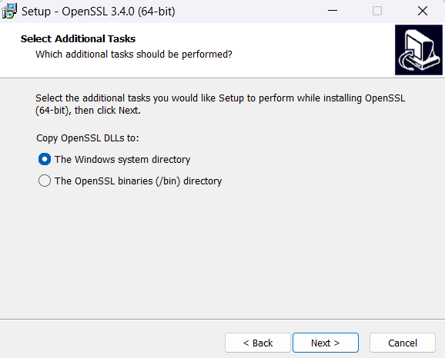

* At this step, it's recommended to select **"The Windows system directory"** for copying the OpenSSL DLLs. This option makes the OpenSSL libraries more accessible to other applications on your system, including Command Prompt.

**Steps to Add OpenSSL to the PATH**

1. **Locate the OpenSSL Installation Directory**:
   * By default, it’s usually installed in C:\Program Files\OpenSSL-Win64 or wherever you chose during the installation.
2. **Copy the Installation Path**:
   * Go to the OpenSSL installation folder, click in the address bar, and copy the full path (e.g., C:\Program Files\OpenSSL-Win64).
3. **Open Environment Variables**:
   * Press **Win + S** and type "Environment Variables" and select **Edit the system environment variables**.
   * In the System Properties window, click on **Environment Variables** at the bottom.
4. **Add OpenSSL to the PATH**:
   * Under **System variables**, find and select the Path variable, then click **Edit**.
   * In the Edit Environment Variables window, click **New** and paste the path you copied earlier (e.g., C:\Program Files\OpenSSL-Win64\bin).
   * Click **OK** to close each window.
5. **Restart Command Prompt**:
   * Close and reopen Command Prompt to ensure the PATH changes take effect.
6. **Verify the Installation**:
   * In the Command Prompt, type:

openssl version

* + If everything is set up correctly, you should now see the OpenSSL version.

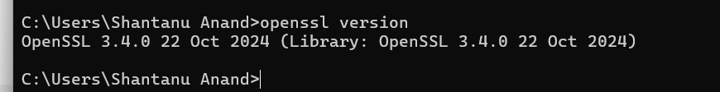

So, navigate to your project directory (cypherchat in this case) and then run:

**openssl req -nodes -new -x509 -keyout server.key -out server.cert**

This will generate the server.key and server.cert files directly in your project folder, making it easy to reference them in your HTTPS server script. Let me know once you’ve generated them, and we can proceed!

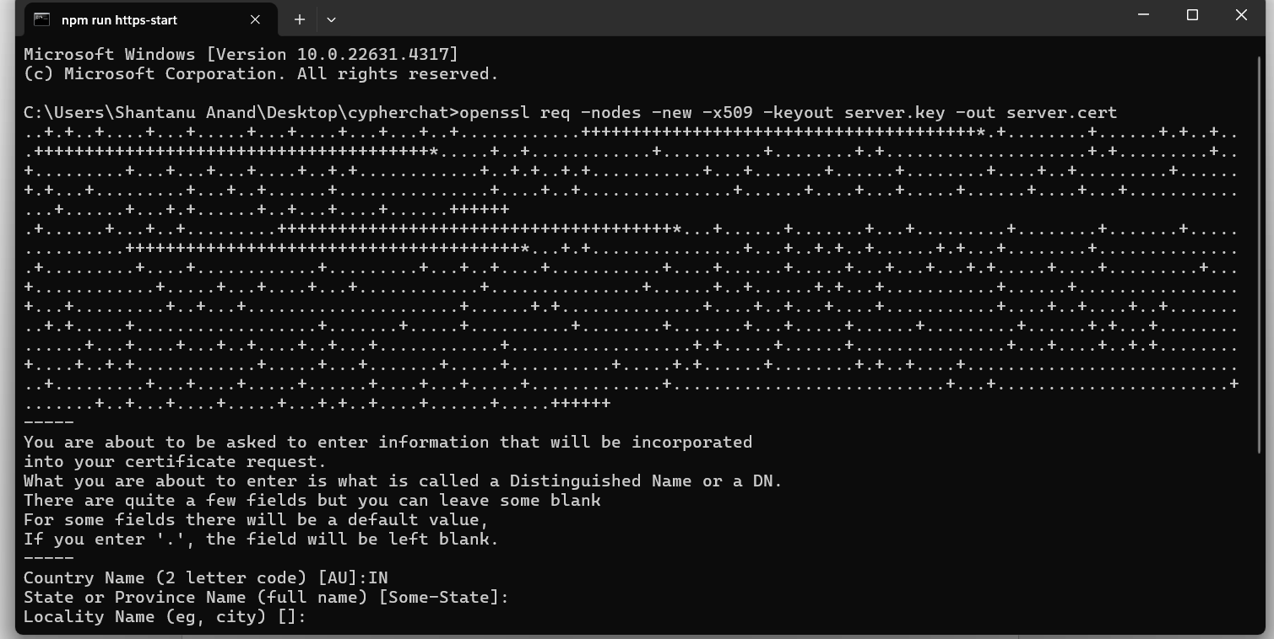

Fill the required details , after that to run with https , enter the following command:

npm run https-start

